**Name**: Karthikeyan K R

**Date**: 03-01-2024

**Topic**: Azure Data Lake

**Type**: Daily Assignment

**Data Lake:**

A data lake is a centralized repository that allows you to store and manage vast amounts of raw data in its native format. Unlike traditional databases that structure and organize data before storing it, a data lake retains data in its original, unprocessed state.

**Benefits of Azure Data Lake:**

* Scalability
* Integration with Azure Services
* Security and Compliance
* Multi-Protocol Support
* Cost-Effective Storage Tiers
* Analytics Capabilities
* Hierarchical Namespace

**Azure Data Lake Storage Gen2:**

Azure Data Lake Storage Gen2 is an enhanced version of Azure Data Lake Storage (ADLS) that combines the capabilities of Azure Blob Storage with the features of the original Azure Data Lake Storage Gen1. It is designed to provide a scalable and secure data lake solution for big data analytics.

**Storage Explorer:**

Azure Storage Explorer is a standalone application that enables you to interact with Azure Storage services, including Azure Data Lake Storage (ADLS), in a user-friendly graphical interface. It provides a convenient way to manage and explore your storage accounts, containers, and files without the need for complex command-line tools.

**Creating a storage account and connecting with storage explorer:**

As we need to create a storage account, we need to choose the storage account service from the azure

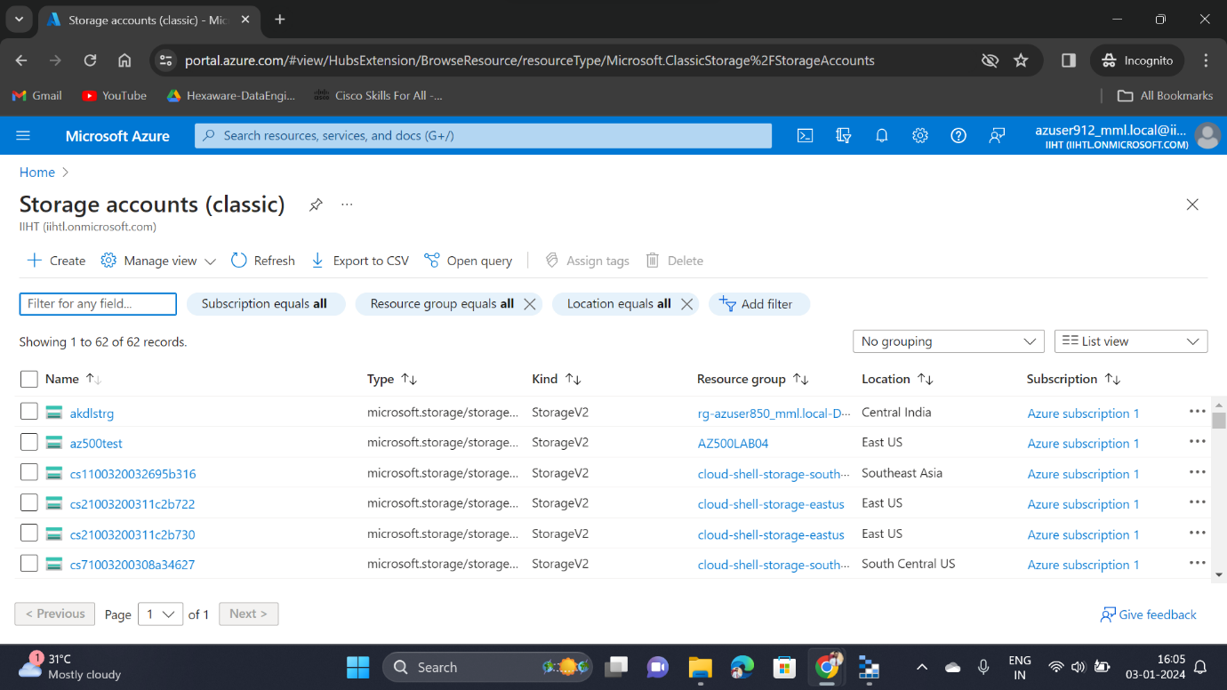

Once we entered into this service page, we can able to see the available storage services. If we need to create a new one, we have to click the Create option which present below the storage accounts

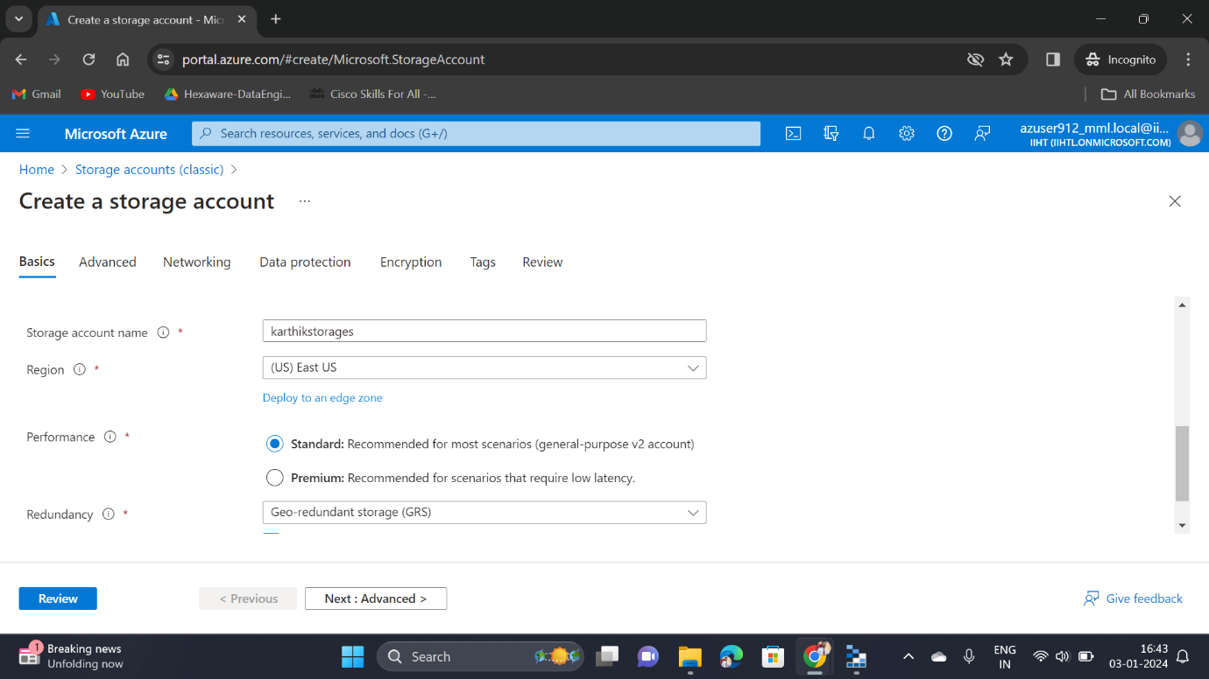

Then we need to click the checkbox for enabling hierarchical namespace option in order to use the Data Lake Storage Gen2

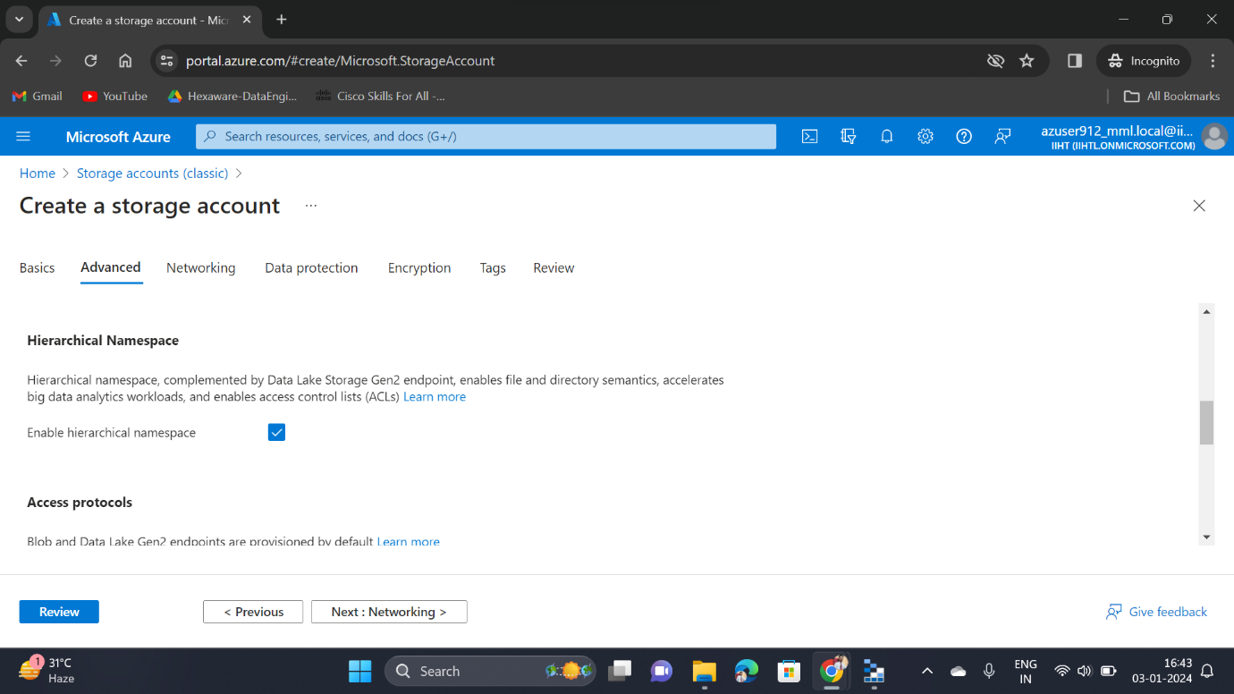

Once created the storage resource service, then go to the resource page

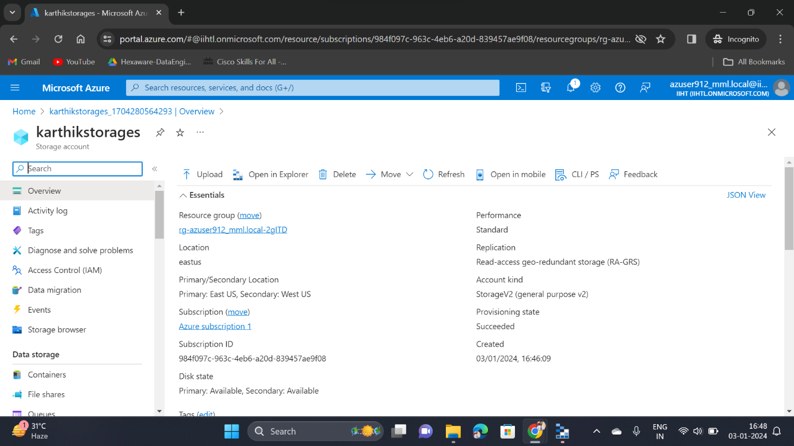

Then go to the containers and create a new one to upload the files

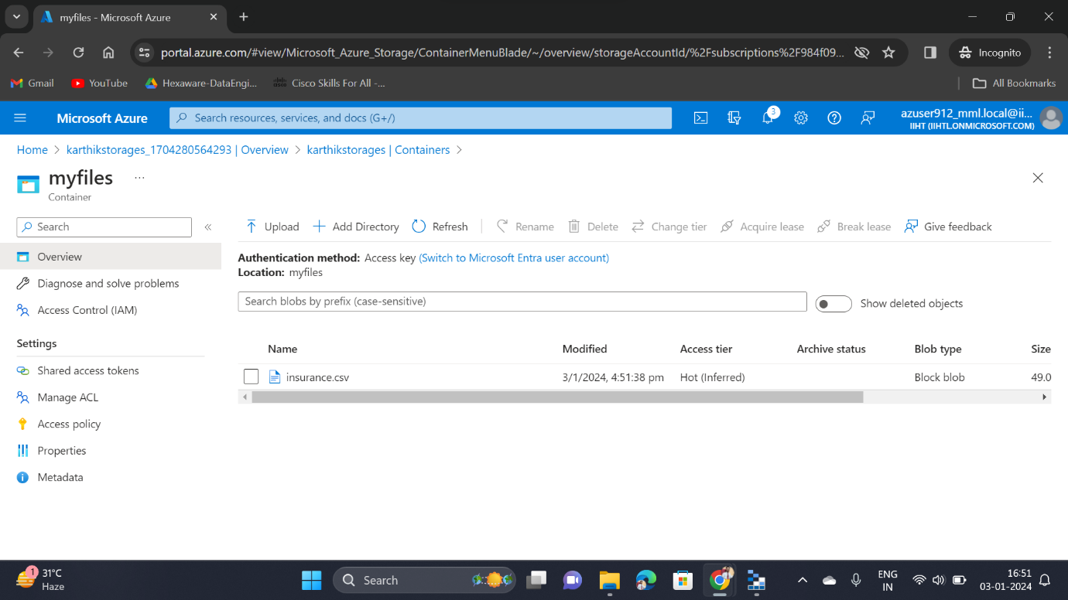

Then open Microsoft Azure Storage Explorer and sign in with your Azure account

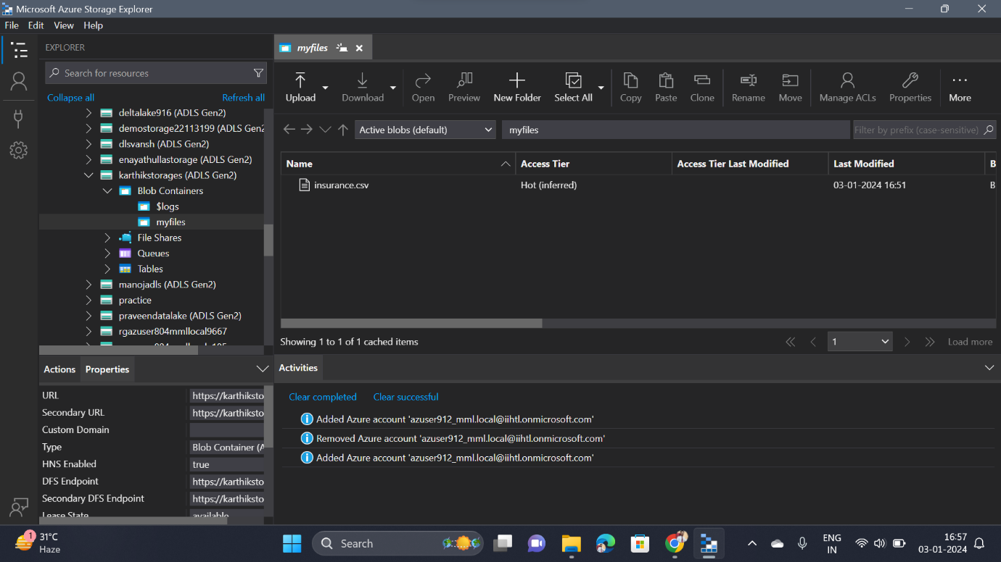

Once get signed-in, go to the storage accounts under the subscriptions in the left pane and there, we can able to access those files that are present in the containers

**Deleting the Storage Service:**

